The Girl Scout Activity Cycle
Give the power of girl leadership, learning by doing, and cooperative learning to your girls! Make sure your girls’ activities go through these four steps:

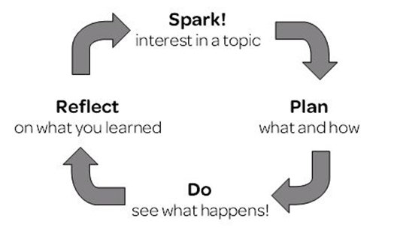
- Spark Introduce the activity to spark their interest and curiosity. Adults can lead an activity, or girls can suggest it and teach each other.
- Plan After girls have some experience with the skill or activity, girls figure out what to do with it. They decide what they want to do (What if I use different soil for my seeds? How can we help the food bank?) and plan how they want to do it.
- Do Girls get busy! They carry out their plan and see what happens.
- Reflect on what they did. They share what they did and learned with others: maybe other girls/adults in the group, their families, or the community.

Tips for the “Spark” Step
- Help girls use the girl guides and journey books to choose their activities.
- To start off, find someone to lead the activity as it’s written – you might show them how to make slime, or girls might team up and teach each other about animal behaviors.

Tips for Planning
- Once girls have done the spark (making paper airplanes, a trip to a food bank), have them come up with ideas for what to do next (how to change their airplane, or how to help the food bank).
- Next, have them choose exactly what they want to do – either in pairs, in teams, or as the whole group. They can vote, come to consensus, or simply work on the idea most interesting to them.
- Give girls some structure as they plan; a list of questions to think about works well. Try “What will you need to do first? Second? Third?”, “What supplies will you need?”, and “Who will do what?”.

Tips for Doing
While girls are working, use open-ended questions to keep them going or get them back on track. Open-ended questions are questions that can’t be answered with a simple “yes,” “no,” or one-word answer. Try:

- Remind me of what your plan was...
- What do you want to do next?
- What happened when…?
- Tell me what you mean by…?
- What other ways could you do this?
- Do you have any new questions now?

Tips for Reflecting
- Have girls draw a picture of what they did and what happened, then tell someone else about their drawing. (Younger girls love this.)
- Ask girls what they liked about an activity, what they didn’t like, and one thing that surprised them.
- Create pages for a group scrapbook that show what they did and learned.

Want some help for your first time using the Activity Cycle? Try the Ring Glider activity on the other side!

 |  | Ring Gliders  The Activity Cycle in Action! |  |  | 
Time: 15-30 minutes
Supplies:
- Paper strips : 1” x 7” & 1/2” x 5” (1 each per girl)  - Non-bending straws (1 per girl)  - Tape (4 pieces per girl; you’ll need a few rolls) |  |  |  | - Extra straws (different sizes)  - Optional: scissors, extra paper
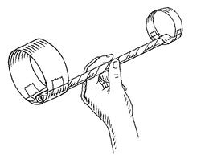
1. Spark!
- Make a basic ring glider as a demo and ask them to follow along:
1. Tape one large strip of paper and one small strip into rings
2. Tape one ring onto each end of the straw
3. Hold the glider like a dart, with the small ring in front
4. Toss into the air
- Once girls have a glider made, have them toss it a few times!
2. Plan “What” and “How!”
- Ask: “What did you notice about how your ring glider flew?”
- Group girls in to pairs. Ask: “What would you like to change about your ring glider?“
- Ask; “How will you change it? Do you need any other supplies (different straws, paper, etc.)? Have them make a quick plan together before they come get more supplies.
3. Do!
- If girls get stuck, try some of these questions:
- Remind me of what your plan was...  - What do you want to do next?  - What happened when... |  |  | - What are some other ways you could do this?  - What else do you want to change now?
4. Reflect!
- Regroup and have each pair share what they did and discovered.
- Ask: “What would you want to try next time you make a ring glider?”
Notes:
- Typical changes include adding more rings, using a different straw, or changing the rings.

 | Created by Girl Scouts of Western Washington and Seattle University as part of the Inquiry in the Community project. This material is based upon work supported by the National Science Foundation under Grant Nos. DRL-0813455 and DRL-0813464. Any opinions, findings, and conclusions or recommendations expressed in this material are those of the author(s) and do not necessarily reflect the views of the National Science Foundation.

