
A Volunteer Learning Resource

Day Trip Planning
PARTICIPANT WORKBOOK


This material is based upon work supported by the National Science Foundation under Grant Nos. DRL-0813455 and DRL-0813464. Any opinions, findings, and conclusions or recommendations expressed in this material are those of the author(s) and do not necessarily reflect the views of the National Science Foundation.

Inquiries regarding this manual should be addressed to:
Volunteer Learning Department
Girl Scouts of Western Washington
601 Valley St., Seattle, WA. 98109
or locate an e-mail address here – www.girlscoutsww.org

My Day Trip Planning facilitator (s) are: ____________________ _____________________ ______________________

If you wish to send us additional thoughts about the session or the facilitators, please feel free to do so by sending your comments to:
Volunteer Learning at Girl Scoutsww.org
Additional Resources that relate to Day Trips can be found at the following link on your Girl Scouts of Western Washington Website:
https://www.girlscoutsww.org/current-volunteers/volunteer-learning/Pages/Learning-Resources.aspx
Copyright © 2013 by Girl Scouts of Western Washington
All rights reserved
DAY TRIP PLANNING
Participant Workbook

TABLE OF CONTENTS

The Foundations of Girl Scouts page 1
The Girl Scout Leadership Experience page 2
The Girl Scout Activity Cycle page 3
Exploring Leadership Progression page 4-5
Progression in Action page 6
Progression in Day Trips page 7
Planning Logistics: Trip Action Plan page 8
Progression in Trips: Planning Logistics page 9-10
Progression in Trips: Planning Activities, Doing the Trip, Reflecting page 11
Girl Scouts of Western Washington Forms page 12
Adult Learning Path page 13
Progression of Outdoor Experiences page 14
Progression of Outdoor Skills page15
A Few "No Cook" Ideas page 16
Key Minimum Impact: Leave No Trace (LNT.org) page 17-18
Resource Sheet of Reflection Activities page 19-20
A Couple of Songs About Nature page 21
Workshop Evaluation page 22-23

THE FOUNDATIONS OF GIRL SCOUTING

The Mission of Girl Scouts
Girl Scouting builds girls of courage, confidence and character, who make the world a better place. – October, 2005
The Girl Scout Program is designed to be an enrichment opportunity where girls can explore their interests building the knowledge, skills at attitudes that will help them to make a difference in the world. The Girl Scout Promise, Law are the foundations of Girl Scouting and provide an ethical base.

Girl Scout Promise
On my honor, I will try:
To serve God, and my country,
To help people at all times
And to live by the Girl Scout Law.

The Girl Scout Law
I will do my best to be
Honest and fair, friendly and helpful,
Considerate and caring, courageous and strong,
and
Responsible for what I say and do,
and to
Respect myself and others, respect authority,
Use resources wisely, make the world a better place, and
Be a sister to every Girl Scout.

the girl scout leadership experience

ACTIVITIES + PROCESSES = GIRL SCOUT LEADERSHIP OUTCOMES
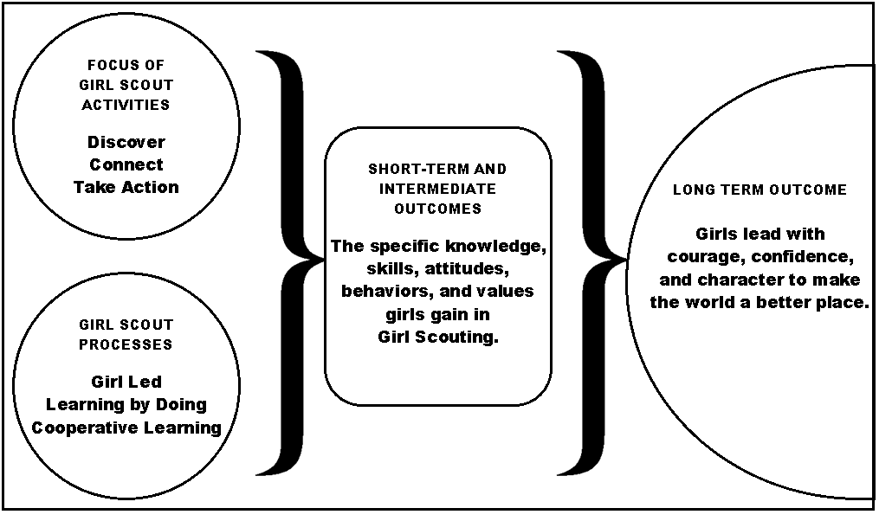

Girl Scout Program Outcomes
GIRLS “DISCOVER”  - Girls develop a strong sense of self.  - Girls develop positive values.  - Girls gain practical life skills.  - Girls seek challenges in the world.  - Girls develop critical thinking. | GIRLS “CONNECT”  - Girls develop healthy relationships.  - Girls promote cooperation and team building.  - Girls can resolve conflict.  - Girls advance diversity in a multicultural world.  - Girls feel connected to their communities, locally and globally. | GIRLS TAKE ACTION  - Girls can identify community needs.  - Girls are resourceful problem solvers.  - Girls advocate for themselves and others locally, and globally.  - Girls educate and inspire others to act.  - Girls feel empowered to make a difference in the world.

THe Girl SCout program Activity Cycle
Girl Scout activities go through cycles of action and reflection. These cycles ensure that girls and adults get chances to learn the basics about a topic, engage in meaningful planning, get hands-on, and reflect on what they did.

- Spark: Introduce an activity to spark interest and curiosity in a subject. This can happen two ways: adults can introduce a topic, or girls can suggest it. Often, the activity introduced is one from a journey or badge, which gives girls a basic understanding of a skill or concept. Girls might learn how to start seeds, make a craft, find out about the needs in their community, or cook a simple meal for camping.

- Plan: After girls have some experience with the skill or activity, girls start thinking about how to make it their own. They decide what they want to do (What if I use different soil for my seeds? How can we help the food bank?) and plan how they want to do it.

- Do: Girls get busy! They carry out their plan and see what happens.

- Reflect: Girls reflect on what they did. They share what they did and learned with others: maybe other girls/adults in the group, their families, or the community. Reflections take many forms, from journaling to parties.

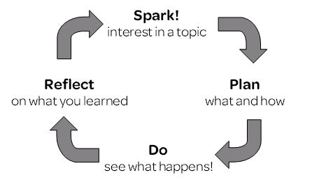

Exploring Leadership Progression: Characteristics

Characteristics of Each Station
A | B | C

Who controlled the…?
For each station, select who controlled each step of the activity: adult, girls, or both?

Station | A | B | C

Spark

Plan, part 1

planning “what” to do

Plan, part 2
planning “how” to do it

Do
issues and solutions

Reflect

Exploring Leadership Progression: Characteristics

During the tops exercise, what did the facilitator do at each station to create each level of control? What did they say, do, have for supplies, etc?
A | B | C

When might it be appropriate to use each of the three approaches?
A | B | C

Progression in Action

Examples of different levels of girl and adult control

 | A: Adult Controlled |  | B |  | C Mostly Girl Controlled
Introduce  “Who chooses what the initial activity is?” | Adults choose the initial activity. | Adults choose an activity based on girls’ interests. | Adults give girls options; girls choose an activity from those options. | Girls and adults generate ideas; girls choose which activity to pursue. | Girls generate ideas based on their interests; girls choose the activity.
Plan, part 1  “Who generates ideas and chooses what girls will do with this activity?” | Adults generate and choose the idea. | Adults make a list of ideas; girls pick which one(s) | Girls brainstorm ideas. Adults eliminate any unworkable ideas; girls choose from this list. | Girls brainstorm ideas. Adults guide girls in evaluating ideas to see if they’re “do-able.” Girls choose. | Girls brainstorm questions, evaluate them for “do-ability” and choose. Adults support as needed.
Plan, part 2  “Who plans the activity?” | Adults make the plan (what, when, where, etc.) | Adults do most of the planning. Adults give girls choices from certain options. | Adults provide framework for planning: how to vote, what decisions need to be made, delegation. Girls make a plan using this framework. | Adults give girls options for how to plan: different ways to vote, delegate, etc. Girls choose from these options, then plan. | Girls decide how they want to plan (delegation, decision making methods, etc.). Adults help girls identify decisions that need to be made, and girls make them.
Do  “When girls are carrying out the activity, who identifies issues and creates solutions?” | Adults identify issues as they arise, and tell girls how to solve them. | Adults identify issues as they arise, and give girls options for how to solve them. Girls choose from these options. | Adults identify issues as they arise, and ask girls open-ended questions to help them find solutions. | Adults ask open-ended questions to help girls identify issues and find solutions. | Girls identify issues as they arise, problem-solve, and carry out solutions. Both girls and adults use open-ended questions to work through issues.
Reflect  “Who identifies what girls did and learned?” | Adults tell girls what they did and learned. | Adults tell girls what they did and learned; girls add additional thoughts. | Adults plan and lead a reflection; girls share what they did and learned. (Adults share their thoughts in the reflection as well.) | Adults identify ways to reflect (drawing, verbal, skits, ceremonies); girls choose. Adults help girls reflect and are included in the reflection as well. | Adults ask girls how they want to reflect. Girls identify ways to reflect, choose one, and carry it out. (Adults are included in the reflection as well.)

Age/experience level of the girls + complexity of the activity = the level of girl control

Progression for day Trips: Deciding Where to Go

Examples of different levels of girl and adult control in planning and taking trips
 | A: Adult Controlled |  | B |  | C: Mostly Girl Controlled
Spark:  Deciding to take some sort of trip, and thinking about trip ideas | Adults choose the initial activity. | Adults choose an activity based on girls’ interests. Girls share | Adults give girls options; girls choose an activity from those options. | Girls and adults generate ideas; girls choose which activity to pursue. | Girls generate ideas based on their interests; girls choose the activity.
Plan - Where  Gathering ideas and making a decision on where to go | I’m choosing the destination. | I’ll give the girls options and they will choose between them. I’ll choose how they make their decision (dot voting, consensus, etc.). | Girls will come up with ideas. I will sort them into groups, and dream box those we don’t have resources for or ability to do it safely. I’ll choose how they make their decision, and they make it. | Girls generate ideas, and then do the grouping and dream boxing with my assistance. I’ll choose how they make their decision, and they make it. | Girls are fully responsible for generating ideas, grouping ideas and dream boxing. We decide together how they’ll make their decision, and they decide. I join in as an equal member in discussions and decision making.

Planning Logistics
Trip Action Plan
Work with your group to answer these questions about the sample trip you’re planning. Think about the age/experience level of your group as you plan, and record your answers on this page.
- People:
  - How many adults do you need? (Look at ratios in Volunteer Essentials and Safety Activity Checkpoints.)
  - What background, experience, skills, certifications, workshops, etc. do those adults need? (Look at Volunteer Essentials and Safety Activity Check points)
  - Who will identify those adults?
  - Who will ask them to join us?
- Equipment/clothing:
  - What equipment / supplies do we need? (Look at Volunteer Essentials and Safety Activity Checkpoints.)
  - What clothing will you need to be comfortable?
  - Who will pack our equipment and supplies?
  - Who will double-check to make sure we have everything?
- Reservations/sites:
  - Do you need reservations for where you’re going? (Reference the Camping on Girl Scouts of Western Washington properties for idea and info on reserving Girl Scout camp sites.)
  - Who will make the reservation?
  - How will they make the reservation? (If you’re going to a Girl Scout camp, look at the reservation process in Camping on Council Properties.)
- Budgeting:
  - How much will this cost?
  - How will you pay for it? (e.g. troop funds, cookie proceeds, parents, etc.)
- Transportation:
  - How will you get there? (e.g. walk, public transit, drive, boat, etc.)
  - What kinds of people do we need to help with transportation? (Volunteer Essentials and Safety Activity Checkpoints, check forms page on )
- Forms:
  - Which forms do you need to fill out? (Look at page 10 in this workbook for a copy of the Guide to Planning a Trip.)
  - Who will fill out the forms?
  - Who will turn in the forms?
:

Progression in Trips: Planning Logistics
 | A: Adult Controlled |  | B |  | C: Mostly Girl Controlled
People  How many people do you need, and with what skills or experience?  Who will identify the needed adults, and who will contact them? | I look through SAC and VE to determine the number of adults and special certifications or skill we need for each activity, I will locate the adults needed. | I teach them how to look through SAC and VE to determine the number of adults and special certifications or skill we need for each activity, I will locate the adults needed. | Girls look through SAC and VE to determine the number of adults and special certifications or skill we need for each activity, I will locate the adults needed. | Girls look through SAC and VE to determine the number of adults and special certifications or skill we need for each activity, I coach them in locating the adults needed. (I might give them names of needed adults and they contact them.) | Girls look through SAC and VE to determine the number of adults and special certifications or skill we need for each activity, they will locate the adults needed.
Equipment  Who decides on individual and group packing lists? How about menus?  Who packs individual stuff, and who packs group gear and food?  Who double-checks to make sure we have everything? | I give the girls a packing list for the trip, their parents do the packing for them at home. I pack the group gear and food needed. I double check to make sure everyone has everything. | I give the girls a packing list for the trip, and girls do their own packing at home. I pack the group gear and food needed. I double check to make sure everyone has everything. | I give the girls a packing list for the trip; they add additional items that they think are missing from the list. Girls pack their own gear at home. We determine the group gear and food together, including menus and an adult does the shopping. We double check each other’s gear and the group gear before we leave. | Girls create the packing list for the trip; I help them think about things they are missing from their list. They pack their own gear at home. Girls determine the group gear and food, including menus, I help them think about things that are missing, and together we do the shopping for the trip. We double-check each other’s gear and the group gear before we leave. | Girls create the packing list for the trip, they pack their own gear at home, girls determine the group gear and food, including menus and do the shopping for the trip. They check each other’s gear and the group gear before we leave.

Progression in Trips: Planning Logistics, Continued

 | A: Adult Controlled |  | B |  | C: Mostly Girl Controlled
Sites  Who decides if you need reservations? Who makes them? | I research the location, I make the reservation | I research the location, I make the reservation. | Girls research the location, I make the reservation. | Girls research the location, I make the reservation. | Girls research the location and make the reservation.
Budgeting  Who decides how much the trip will cost? Who decides how it will be paid for? (Troop funds, cookie proceeds, parents, fundraising, etc.) | I determine how much the trip will cost, and how the trip will be paid for. | I determine how much most of the trip will cost, I choose one or two costs that the girls budget for (e.g. admission fees). I choose how the trip will be paid for. | I do the budgeting for half of the trip items; girls budget the other half. Girls choose how to pay for the trip. | Girls do the budgeting for most of the trip; I double-check their work, and budget any particularly challenging items. Girls choose how to pay for the trip. | Girls do the budgeting for the trip, and double-check each other’s work. They decide how to pay for the trip.
Transportation  Who decides the mode of transportation? Who decides how to get there? | I decide our mode of transportation and how to get there. | I give girls options for a mode of transportation; girls choose which one. I decide how to get there. | I help girls decide which mode of transportation to use. I teach them how to figure out how to get there (reading maps, bus schedules, etc.) | Girls decide their mode of transportation. The girls decide how to get there; I help as needed and double-check their plans. | Girls decide their mode of transportation, and how to get to their destination. They double-check their plans.
Forms  Who decides what forms you need, fills them out, and turns them in? | I decide what forms we need, fill them out, and turn them in. | I decide what forms we need. I teach the girls how to fill them out, and I turn them in. | I decide what forms we need. The girls fill them out, and I turn them in. | I help the girls decide what forms they need. They fill them out, and I help them turn them in. | Girls decide what forms we need; they fill them out, double-check them, and turn them in.

Progression in Trips: Planning Activities, “Doing” the Trip, and Reflecting

 |  | A: Adult Controlled |  |  | B |  | C: Mostly Girl Controlled
Activities  Who decides what activities you will do on your trip? Who plans and leads those activities? | I will locate activities for the girls to do from the resources and plan the program for the day. |  | I will determine 3 options of activities for the girls to choose one for the trip. |  | I will provide a set of cards with different activities for the girls to look through and choose at any time during the duration of the trip. | We will work together to create a set of possible activities to do. Once we have created a list they girls will be able to choose what to do when. | The girls will work together to determine the activities that we will do while on the trip. Each girl will have their own activity to be in charge of and lead the rest of the girls through it.
Do  When we’re taking the trip, who will identify problems, and figure out how to solve them? | I will identify problems as they arise, and I will solve them. |  | I will identify issues as they arise, and give girls options for how to solve them. Girls choose from these options. |  | I will identify issues as they arise, and ask girls open-ended questions to help them find solutions. | I will ask open-ended questions to help girls identify issues and find solutions. | Girls identify issues as they arise, problem-solve, and carry out solutions. Both girls and adults use open-ended questions to work through issues.
Reflect  Who decides what the reflection activities will be? | I choose a reflection activity for the girls to participate in. |  | I have a set of questions to ask the girls as a group throughout the activity. Their responses will shape the reflection activity that we will do at our following troop meeting. |  | I provide a set of questions for girls to ask each other during the trip. Their answers will inform the reflection activity that we will do at our next troop meeting. | I provide multiple opportunities for open reflection during the field trip. The girls discussions during these open times will guide their reflection planning for after the trip. | The girls create multiple opportunities for open reflection during the field trip. The girls’ discussions during these open times will guide their reflection planning for after the trip.

Girl Scouts of Western Washington Forms
The Guide to Planning a Trip is intended to help traveling groups organize forms that need to be completed prior to departure. Please use this form as a planning checklist as your group plans their trip. Copies of each form are available on the Girl Scouts of Western Washington website at https://www.girlscoutsww.org/current-volunteers/forms/Pages/default.aspx. All forms should be turned in to your Girl Scouts of Western Washington staff representative unless otherwise noted below. Please note that if you do not turn the forms in by the required due date, your travel will not be approved.

Form | Description or Purpose | Due Date  [for Girls and Advisors] | Due Date  [to GSWW] | Date Submitted  [to GSWW]
APPLY FOR SOME DAY TRIPS, ALL 1-2 NIGHT TRIPS, OR 3-NIGHT TRIPS OVER A U.S. FEDERAL HOLIDAY* WEEKEND:
Permission for Meetings, Day Trips and Medical Care | - Completed by the parent/guardian and returned to the troop/group leader for all troop/group meetings and day trips  - This form will be retained by the troop/group leader for one year and accompany the adult in charge at all meetings and other activities (i.e. field trips, camping, etc.) |  | N/A | N/A
Parent Permission for Overnight Trips and Sensitive Topics | - Complete for all overnight trips and/or day trips involving sensitive topics  - Form is completed by the parent/guardian and returned to the troop/group leader |  | N/A | N/A
Application for High Risk and Sensitive Topics | - Complete for activities involving special equipment, sensitive issues and/or identified in Volunteer Essentials and/or the Safety Activity Checkpoints https://www.girlscoutsww.org/current-volunteers/pages/volunteer-essentials-and-safety-activity-checkpoints.aspx  - Additional insurance may be required depending on activities/participants. Information and forms available in the Forms section of the GSWW website.  - Submit to your Service Unit Manager 1 month prior to in-council travel and 2 months prior to out-of-council travel  - If you are traveling internationally (including Canada), check identification and permission guidelines, and submit this form to GSWW staff representative, instead of Service Unit Manager
Policy on Administering Medication to a Minor | The policy includes the following sections:  - Written authorization and instructions from medial provider in regards to administering medication  - Parental permission form  - Volunteer confirmation of receipt of written authorization and instructions |  | N/A | N/A
Girl or Adult Health History Record | - Completed by parent/guardian of girls or by adult members for themselves.  - Form is returned to the troop/group leader or adult in charge of the event. |  | N/A | N/A
Additional Insurance | - Forms must be submitted 4 weeks prior to departure  - Information and forms available in the Forms section of the Girl Scouts of Western Washington website.  - For day trip, can be purchased if non-registered adults or children attend
Emergency Procedures Card | - Explains Girl Scouts’ procedures for handling an incident or emergency.  - The adult(s) in charge must carry card and a GSWW Accident Claim Form during all Girl Scout activities. | N/A | N/A | N/A
Transportation Card | - Adults driving for Girl Scout activities complete this form and return it to the adult in charge.  - All drivers must be at least 21 years old and have had their licenses for at least 3 years. |  | N/A | N/A

PROGRESSION OF OUTDOOR EXPERIENCES
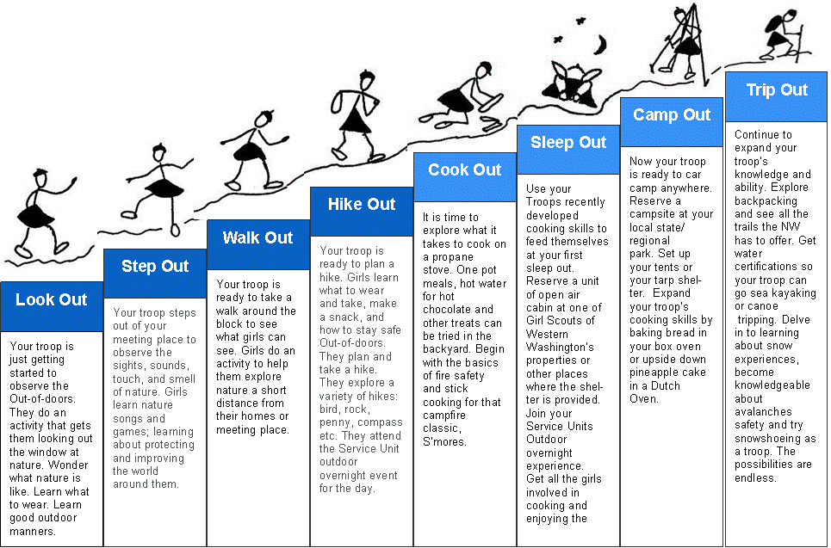

progression in outdoor skills
 | AGE 6 | AGE 7 | AGE 8 | AGE 9-10-11 | AGE 12-13 | AGE 14-15
General | Practice Leave No Trace Skills | Know how to roll a sleeping bag.  Know what to take on a hike. | Know what to take on an overnight trip and go on an overnight. | Practice overall camp craft on an overnight. | Be able to improvise and use equipment. Help pack food and equipment efficiently. Learn primitive camping skills. | Take charge of a cookout. Go on an extended camping trip. Learn survival skills. Try canoe camping or backpacking.
Orienteering | Know what to do if you are lost. | Sketch a map of playground and orient it to the surroundings. | Find North on a compass. Know good hiking practices and use them. | Know how to read and use a road map and a topographic map. Know how to tell directions with a compass. | Find directions using a map and compass adjusting for declination. Follow a bearing. | Participate in an orienteering club meet or set up your own course.
Knots |  | Learn the square knot, how and when it is used. | Learn the clove hitch and its uses. | Become proficient with the previously learned knots. Learn the bowline. | Learn the half hitch and taut line. | Learn how to whip and coil a rope. Learn about the various kinds of rope and how to care for it. Try splicing.
Tools |  | Learn knife safety and how to use and care for a knife. | Learn how to sharpen a knife. | Learn the parts of a tent; pitch and strike one. Learn to use a bow saw. | Learn how to use a hatchet and ax. | Learn how to sharpen a hatchet and ax
Health & Safety | Help clean up after a cookout. Know safe wading practices. | Know how and where to dispose of garbage, paper, and liquids. Know what to do for a burn or cut. Be able to identify poison oak. | Organize a dishwashing setup and properly dispose of gray water. | Know how to care for fainting, sprains and simple accidents. Take charge of cleanup after a cookout. Know how to dig a cat hole. | Practice basic first aid procedures.  Know how to purify water. | Take a Red Cross Standard First Aid course (which includes adult CPR). Learn how to deal with emer. In backcountry.

A FEW NO-COOK IDEAS
Preparing these foods will begin to acquaint girls with cooking equipment and tools, food preparation and hygiene.
Walking Salad - Core small apples (or apple halves dipped with lemon juice and water). Stuff with 2 tsp. Miracle Whip, cream cheese or peanut butter mixed with chopped celery, nuts, raisins or chopped dates.
Ants on a Log or Bugs on Snow - Stuff celery sticks with peanut butter or cream cheese. Line stuffing with raisins.
Applewiches - Spread apple slices with peanut butter or cheese spread.
Pudding Cones - Prepare any flavor instant pudding. Use to fill ice cream cones just before serving. Can be topped with marshmallow topping, pie filling, chopped nuts, etc, or added on top of sliced bananas already in the cone.
Rainbow Pudding - Prepare instant vanilla pudding. Swirl a small package of M&Ms through the pudding just before serving.
Carrot Wheels - Dip slices of large carrots in peanut butter or cream cheese thinned with a little honey
Quick Banana Boats - Slice bananas. Mix with Cool Whip, chocolate chips and mini-marshmallows
Toothpick Kabobs - Use any combination of small cubes of cheese, meat, Vienna sausage, pickles, fruit. String on toothpicks.
Miniburritos - Use round corn chips to assemble bite-sized burritos with refried beans, grated cheese, chopped lettuce, salsa, etc.
Veggie Patch - Use ranch dressing for a dip. Serve with assorted raw vegetables such as cauliflower, broccoli, carrots, jicama, zucchini and cucumbers.
Roll-M-Ups - Cream cheese or peanut butter and raisins rolled in a lettuce or Chinese cabbage leaf or a stick of cheese and a pickle rolled in a cold cut slice.
Salad on a Stick - String assorted vegetables on a skewer. Dunk in salad dressing.
Cottage Cheese Crunch - Chop crunchy vegetables and mix with cottage cheese.
Candles - Place a pineapple ring on a lettuce leaf. Stand ¼ or ½ banana in center of ring. Spoon on Miracle Whip, if desired. Top with a maraschino cherry on a toothpick.
Friendship Salad - Each person brings a piece of fruit. Dice the fruit and mix with a little honey and a dash of lemon juice or mix with undiluted frozen orange or apple juice concentrate. Mini-marshmallows and nuts can be added.

Key minimum impact concepts; Leave No Trace (LNT.org)

Plan Ahead and Prepare
    - Know the regulations and special concerns for the area you'll visit.
    - Prepare for extreme weather, hazards, and emergencies.
    - Schedule your trip to avoid times of high use.
    - Visit in small groups when possible. Consider splitting larger groups into smaller groups.
    - Repackage food to minimize waste.
    - Use a map and compass to eliminate the use of marking paint, rock cairns or flagging.

Travel and Camp on Durable Surfaces
    - Durable surfaces include established trails and campsites, rock, gravel, dry grasses or snow.
    - Protect riparian areas by camping at least 200 feet from lakes and streams.
    - Good campsites are found, not made. Altering a site is not necessary.
    - In popular areas:
    - Concentrate use on existing trails and campsites.
    - Walk single file in the middle of the trail, even when wet or muddy.
    - Keep campsites small. Focus activity in areas where vegetation is absent.
    - In pristine areas: Disperse use to prevent the creation of campsites and trails.
    - Avoid places where impacts are just beginning.

Dispose of Waste Properly
    - Pack it in, pack it out. Inspect your campsite and rest areas for trash or spilled foods. Pack out all trash, leftover food, and litter.
    - Deposit solid human waste in catholes dug 6 to 8 inches deep at least 200 feet from water, camp, and trails. Cover and disguise the cathole when finished.
    - Pack out toilet paper and hygiene products.
    - To wash yourself or your dishes, carry water 200 feet away from streams or lakes and use small amounts of biodegradable soap. Scatter strained dishwater.

Leave What You Find
    - Preserve the past: examine, but do not touch, cultural or historic structures and artifacts.
    - Leave rocks, plants and other natural objects as you find them.
    - Avoid introducing or transporting non-native species.
    - Do not build structures, furniture, or dig trenches.

Minimize Campfire Impacts
    - Campfires can cause lasting impacts to the backcountry. Use a lightweight stove for cooking and enjoy a candle lantern for light.
    - Where fires are permitted, use established fire rings, fire pans, or mound fires.
    - Keep fires small. Only use sticks from the ground that can be broken by hand.
    - Burn all wood and coals to ash, put out campfires completely, then scatter cool ashes.

Respect Wildlife
    - Observe wildlife from a distance. Do not follow or approach them.
    - Never feed animals. Feeding wildlife damages their health, alters natural behaviors, and exposes them to predators and other dangers.
    - Protect wildlife and your food by storing rations and trash securely.
    - Control pets at all times, or leave them at home.
    - Avoid wildlife during sensitive times: mating, nesting, raising young, or winter.

Be Considerate of Other Visitors
    - Respect other visitors and protect the quality of their experience.
    - Be courteous. Yield to other users on the trail.
    - Step to the downhill side of the trail when encountering pack stock.
    - Take breaks and camp away from trails and other visitors.
    - Let nature's sounds prevail. Avoid loud voices and noises

Resource Sheet of Reflection Activities
About Reflection
When reflecting on an experience, you want your girls to answer three “big picture” questions. They are:

- What? Girls describe, objectively, what they just did. Some specific phrases for “what” are:
  - Describe (draw a picture, act out) what we just did.
  - What happened?
  - What did you notice/observe?
  - Who noticed something different? What was it?
  - What did you feel during the activity? (Younger girls do well drawing – or choosing - a picture of a face that’s happy, sad, frustrated, etc.)

- So What? Girls shift from describing to interpreting what the experience meant. Try saying:
  - Explain why you did it that way.
  - What did you learn about __________ (the topic or experience)?
  - What does that mean to you? (Example: what does “she didn’t listen” or “I felt confused mean to you?)

- Now What? Girls think about how they can apply what they’ve learned.
  - If you were going to do this again, what would you do differently? The same?
  - What did you learn (about each other, about the topic/skill) that will be useful the next time we (have a meeting, explore this topic, do a similar activity)?

Individual Reflection Activities
Here are some ways to have girls reflect on their own.

Check in ideas (best done in a circle)
- Each girl shares one to three words to describe the activity or how you feel about the activity or to a question.
- Have the girls express their feeling about the activity in a theme, the weather, a color etc…
- Have girls check in with some sensory stimuli (sound, smell, sight) highlight.
- Each girl makes a face, a sound, or movement capturing how they felt about what happened.

Written Reflection-Pose three or four questions, using “what, so what, now what” model, and allow time for writing. (i.e. What you did, why/how you did it, how you could do it better)
Journaling-Each person responds to a question in writing
Letter to self - Prior to a activity, have participants write a letter to themselves about their goals regarding, or feelings. Place it in a sealed envelope, mail it to yourself or hand out again after six months and reflect.
Cartoon - Draw a cartoon that teaches something important regarding the activity.

Resource Sheet of Reflection Activities, Continued

Group Reflection Activities
These ideas get girls to think together about their experience.
Snapshot - Create a silent snapshot of the activity. One person starts with a pose or action related to the activity, everybody else joins the “snapshot.”
Poetry/Writing Slam - Each girl takes a turn to write a short poem or sentence about the activity, then share it with the group.
Sculptor - One participant chooses a topic and asks for a set amount of participants to be the clay. The “clay” people let the “sculptor” mold them into the sculptor's vision of their topic – for example, invasive plant removal, the experience the group just had together, or the plight of someone who is homeles.
Yarn Web - Stand in a circle with a ball of yarn. Each person throws it to another and says one word that explains what happened, what they appreciated in the person they are throwing it to, what they learned, etc.
Pictionary - Have a Pictionary game about the experience and how you felt. Talk about it as a group.
Parables/Stories - Read a piece of pertinent literature and have participants respond and draw correlations to the experience.
All on the Wall - Put a large piece of paper up on one wall or all the way around the room. Girls write or draw feelings/thoughts/learnings on the paper.
Object share - Each person brings in and passes around an object, and shares how the object is like them or the activity they just did.
How did it taste - Bring a mixture of fruits and nuts, have them use these items as metaphors to describe their day, week, experience, group interaction, etc, and answer the question, “how did it taste?” Then, “what would you like it to taste like?”
Teach - Teach others what you learned through the experience. Put together instructions or references for learning more about it.
Media - Share the experience via social media, with the council blog, podcast or the website.

A COUPLE OF SONGS ABOUT NATURE
THE FROGS
HEAR THE LIVELY SONG OF THE FROGS IN YONDER POND,
KRIK, KRIK, KRIKITY KRIK, BRRR –RR-RUM
Can be found in Sing Along Song Book, page 20; Sangam Songbook, page 127

I LOVE THE MOUNTAINS
I LOVE THE MOUNTAINS, I LOVE THE ROLLING HILLS,
I LOVE THE FLOWERS, I LOVE THE DAFFODILS;
I LOVE THE FIRESIDE WHEN ALL THE LIGHTS ARE LOW.
BOOM DEE AH DA, BOOM DE AH DA, BOOM DEE AH DA, BOOM DEE AH DA

Can be found in Sing Along Song Book, page 20; Sangam Songbook, page 129

WORKSHOP EVALUATION – DAY TRIP PLANNING
On a scale of 1 – 10 (1 = poor and 10 = excellent)
- I would rate this workshop:
1 2 3 4 5 6 7 8 9 10
Comment:
- I understand what “girl led” can look like and when using the different A, B, and C approaches are appropriate.
1 2 3 4 5 6 7 8 9 10
Comment
- I know how to consider how much control to give my girls over each step (planning, doing, reflecting) of an day trip activity.
1 2 3 4 5 6 7 8 9 10
Comment:
- I know what the steps (Trip Action Plan) are to help girls plan, do and reflect on an adventure away from their regular meeting place.
1 2 3 4 5 6 7 8 9 10
Comment:
- I am aware of resources available to me and my girls to help meet the requirements and plan for, take and reflect on a Day trip.
1 2 3 4 5 6 7 8 9 10
Comment:
- I understand how the concept of “Girl Led” can apply to any activities our troop might choose to pursue.
1 2 3 4 5 6 7 8 9 10
Comment:
- Three things I found most valuable in this workshop were:
- _________________________________________________
- _________________________________________________
- _________________________________________________
PLEASE TURN OVER

- Facilitator evaluation. Please indicate your assessment of the trainers’ skills in presenting this course using a scale of 1 – 4, 4 being the highest value. For each trainer check the box for the value of your choice for each statement.
Facilitator Facilitator Facilitator
Name Name Name
____________ ___________ _ _________
 | 1 | 2 | 3 | 4 | 1 | 2 | 3 | 4 | 1 | 2 | 3 | 4
Appeared to be prepared
Appeared to be competent in the subject matter
Gave clear and concise instructions
Encouraged group involvement and participation
Handled discussions and problems from the group
Used a variety of facilitation methods (instructional strategies)
Worked well with co-facilitators (if applicable)
- Other comments:

