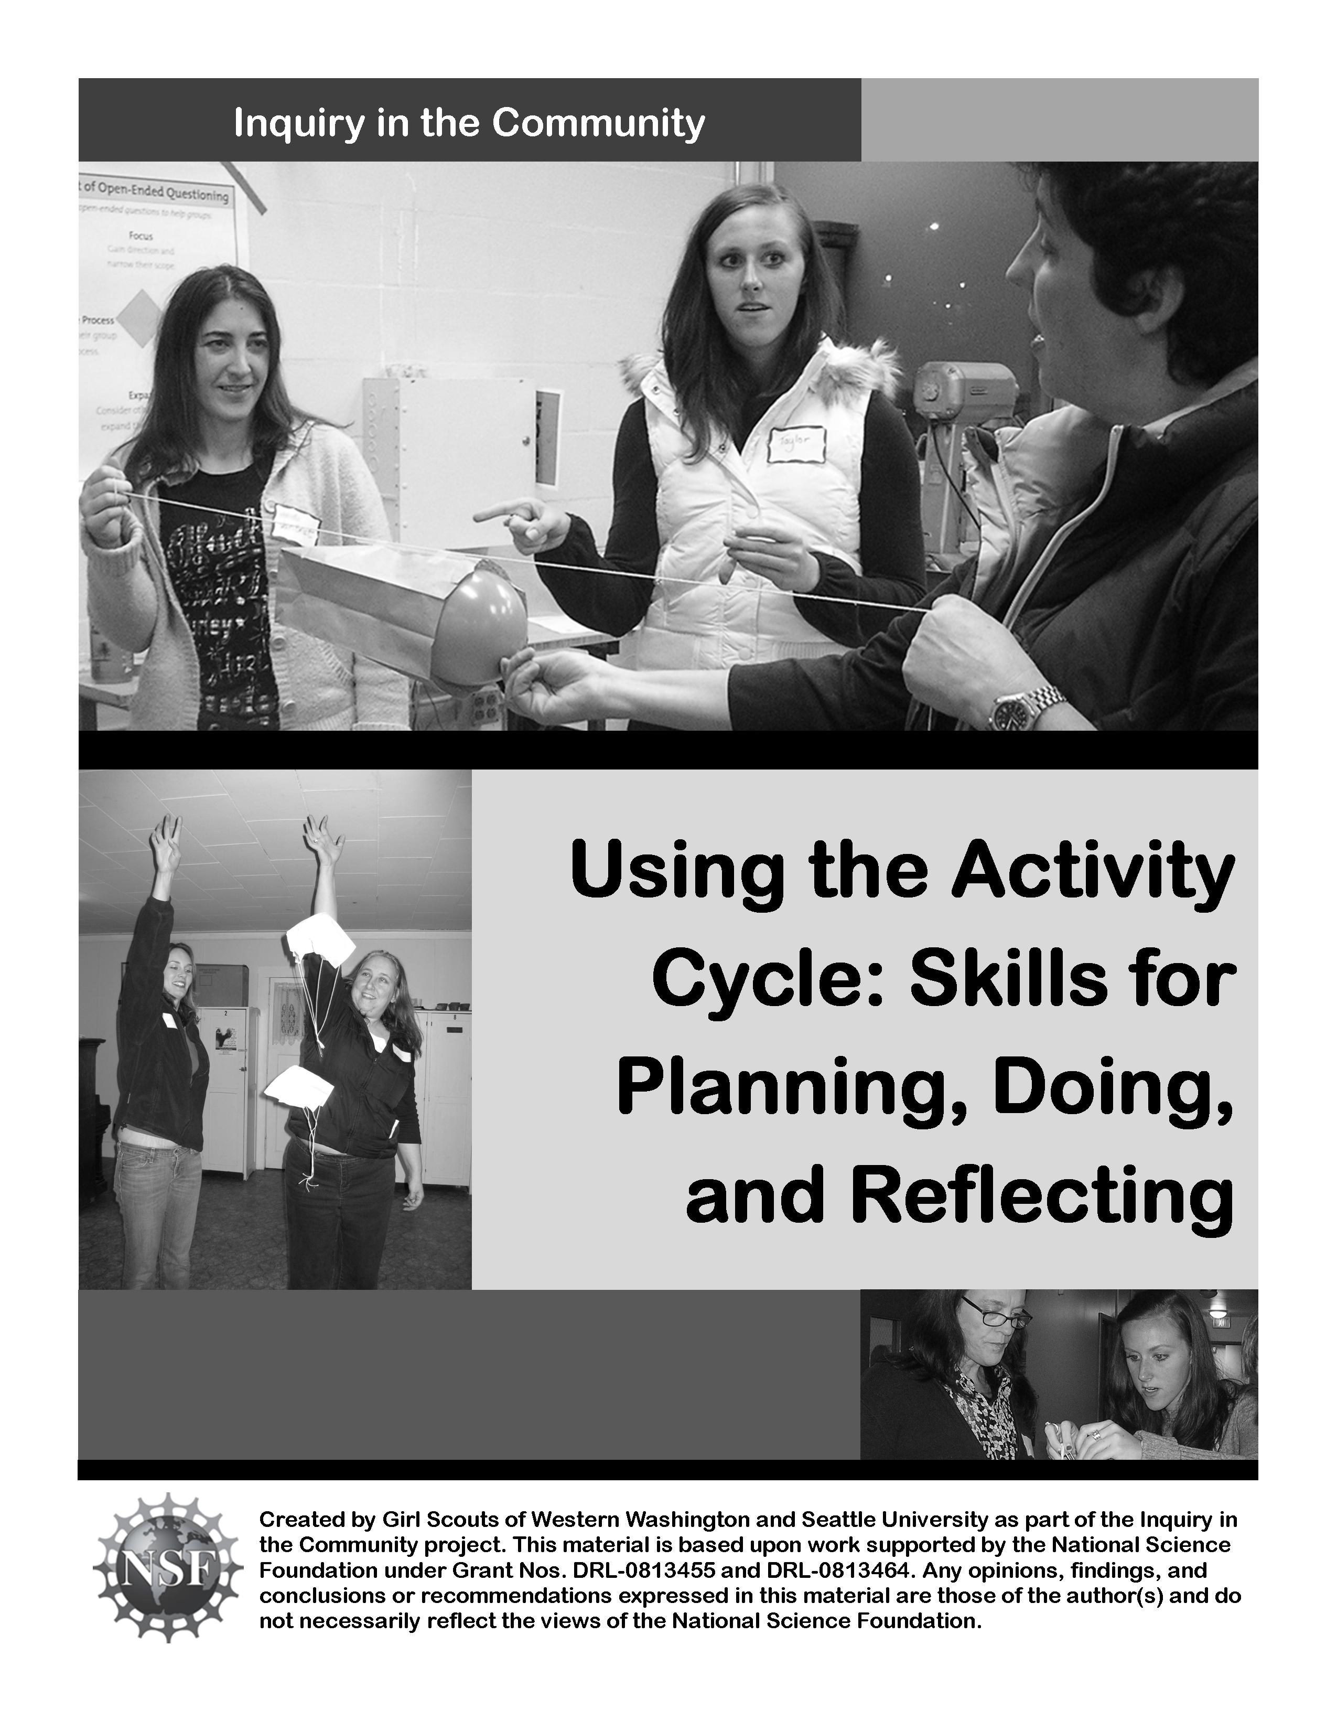

Opening

Opening Ceremony:
If you choose to use this opening ceremony with others, you will need one long length of cord or rope, tied in a circle. (Hint: if you know how to tie one, an adjustable knot, like a slipknot or trucker’s hitch, can help you fit the cord/rope to the size of your group.)

- Lay the rope down on the floor and spread it out so it forms a circle.
- Invite the girls/adults to stand with you in a circle around the rope.
- Pick up the part of the rope that is nearest you.
- Welcome the group, and give the instructions for the opening ceremony. Your instructions might go like this:
- “One by one, you’ll take turns picking up the rope and joining the circle of your sister Girl Scouts. Once you’ve picked up the rope, share your name and two words that describe how you’re feeling right now. Then it will be the next person’s turn.”
- Once everyone has picked up the rope, say the Girl Scout Promise and Law.
- Count to three, and have everyone set the rope down together.

Ceremonies like this are endlessly adaptable. You can…
- Modify what you have the girls share. It can be a name and a two-word check-in, as described above, what they’re excited about in Girl Scouting, or a response to another question you pose.
- Have girls write what they’ve shared (name and response to your question) on an index card. Then, have girls tape the card to the rope as they share their thoughts.
- Or, bring a few pieces of scrap ribbon. Have girls choose a small piece of ribbon to represent them and tie it to the rope as they share their thoughts.
- Sing a short song.
- Share a quote or poem. Try this quote, by Juliette Gordon Low, the founder of Girl Scouting in the USA: “Girl Scouting can be the magic thread which links the youth of the world together.”

This ceremony is similar to one used in the Agent of Change journey for Girl Scout Juniors.

Agenda and Group Agreement

Agenda:
In this workshop, you’ll learn lots of ways to help girls plan, implement, and reflect on activities. Today you will…
- Review the Girl Scout Activity Cycle and how it’s used to plan activities for girls
- Experience ways to help girls generate ideas and questions, and to “turn” any unanswerable questions into answerable ones
- Explore different planning tools you can use with girls: resource checks, decision-making strategies, and ways to delegate
- Learn and practice ways to use open-ended questions to help girls as they work
- Experience two different ways to help girls reflect on what they’ve done and learned.

Our Group Agreement:

The Activity Cycle

Girl Scout activities go through cycles of action and reflection. When working with girls, it is helpful to think of an activity as having four different steps. By using these steps to frame our activities, we ensure that girls get chances to learn the basics about an activity or topic, have meaningful planning opportunities, have hands-on fun, and reflect on what they did.

Activity Cycle:

- Spark! Introduce an activity to spark interest and curiosity in a subject. This can happen two ways: adults can introduce a topic, or girls can suggest it. Often, the activity introduced is one from a journey or badge, which gives girls a basic understanding of a skill or concept. Girls might learn how to start seeds, make a craft, find out about the needs in their community, or cook a simple meal for camping.

- Plan After girls have some experience with the skill or activity, girls start thinking about how to make it their own. They decide what they want to do (What if I use different soil for my seeds? How can we help the food bank?) and plan how they want to do it.

- Do Girls get busy! They carry out their plan and see what happens.

- Reflect on what they did. They share what they did and learned with others: maybe other girls/adults in the group, their families, or the community. Reflections take many forms, from individual journaling to group slide shows and year-end parties.

The “do” and “reflect” steps often bring up new ideas, and the steps start all over again!

The Activity Cycle: Planning “What”

“Action” and “No-Action” Questions

Turning Questions: One Example

With balloon rockets, one question often asked is: “Why does the balloon make it go?”

To turn this question, we look for a variable to change. The most obvious is the balloon.

What are some ways we can change the balloon? We could…
- Use a bigger balloon
- Use a smaller balloon
- Use a different color balloon
- Fill the balloon half-way with air
- Fill the balloon with something else

These changes lead us to some new, action questions:
- What happens if we use balloons of different sizes?
- What if we fill the balloon with different amounts of air?
- What happens if we fill the balloon with water?

Action questions suggest the next steps to take. Examples are:
- What if we use a bigger balloon?
- Does placing the string at an angle change how fast it goes?
No-action questions don’t suggest next steps to take. Examples are:
- Why does the balloon make a noise?
- How does the air make it move?

Turning Questions into Action Questions
If your girls come up with a lot of no-action questions, turning some into action questions can give you – and them – more options.
- Look for variables. (Hint: look for nouns!)
- Come up with ways to change one variable.
- Come up with ways to change the other variables.
- Share these new questions with the girls.

Now, You Do It!
Your No-Action Question:

Some New Action Questions:

The Activity Cycle: Planning “How”

Summarize
Look for questions/ideas that seem similar and group them together. (Tip for Daisies: their “questions” will more often be “statements of things they would like to change/do.” Just rephrase these as questions and proceed! Over time, they will be more able to follow your example and make questions of their own.) In balloon rockets, for example, you could group all the balloon questions together, and all the paper bag questions together. This makes your list smaller and more manageable.

Resource Check
This can take a few minutes (balloon rockets) or a few meetings (planning a trip to Mexico). Try to answer:
- Do we have enough time?
- Do we have enough resources? (Supplies, money, people, etc.)
If a question or idea doesn’t pass the “resource check,” put it in a “Dream Box.” Hang onto those ideas – you can use them later! (Daisy tip: you will need to answer the “time” question. Keep the “resources” simple and tangible.)

Choose
There are many ways to choose. You can talk until you have consensus (more appropriate for older girls making large decisions), or use a voting method. We did two in this workshop:
- Dot Voting: Give each person a pre-determined number of sticky dots (or whatever object you have handy.) Each person can distribute their votes how they wish: put them all on their favorite idea, or spread them out between a couple interesting ones.
- Vote With Your Feet: Assign each question/idea a location in the room. When you say “vote,” girls stand next to their favorite idea. The one(s) with the fewest girls are eliminated. Repeat until you have a winner(s).

Delegate
Depending on the scope of the question/idea, you may want to break it down into smaller pieces. Have small groups take charge of sub-questions (bigger balloons, smaller balloons, different colors, etc.) or of group needs (food, activity planning, transportation, etc. for a trip to the zoo). It often helps to have an adult with each group to keep girls on track – particularly with younger girls.

The Activity Cycle: Doing

The Art of Open-Ended Questioning
When groups need prodding or help, they usually need to do one (or more) of the following actions. You can help the group by asking open-ended questions to get them moving. (Open-ended questions are those that can’t be answered with a simple “yes” or “no.”)
Focus
Help groups gain direction and narrow their scope.
“What do you want to do?”
“Who has an idea? What is it?”
“What part of this idea do you want to do now?”
Support
Help groups make plans & add more detail.
“What do you want to do next?”
“Can you explain what you mean by…?”
“Then what?”
“And…?”
Notice Process
Help groups “see” their group process.
“What ideas have your teammates contributed?
“What ideas have each of you shared?”
“It seems like everyone is talking at once…”
“Which jobs are each of you doing?”

Expand
Help groups consider other ideas and expand their thinking.
“What other ways could you do this?”
“What do you think about _____?”
“How might someone else do this?”

The Activity Cycle: Doing

Scenario #1
This week you are doing a parachute activity with your troop. The girls have many questions, and they are excited about investigating parachutes. However, one group is having a hard time organizing their experiment. They want to investigate the speed of a falling parachute as well as what causes a parachute to spin as it falls. As a result, they are launching their parachutes with little agreement about what they’re investigating.

Does this group primarily need to focus, support, expand, or notice process?

Questions to help them:

Scenario #2
This week you are doing a parachute activity with your troop. You have sparked their interest with a basic parachute, and the girls have come up with many questions. One group wants to investigate the question “How do we make a parachute land faster?” The girls have a lot of ideas about using weight to make it land faster, but can’t seem to get a cohesive plan together. The girls don’t know what to do next.

Does this group primarily need to focus, support, expand, or notice process?

Questions to help them:

The Activity Cycle: Doing

Scenario #3
This week your troop is investigating balloon rockets. You show everyone your example rocket, lay out the materials, and then encourage the girls to experiment with their own balloon rockets. As the girls are investigating, you overhear two groups discussing what they have found. They have attributed their balloon rocket’s speed to the color of their balloon, claiming that the red balloons go faster than the blue balloons. They think that they have “solved” their question. You are skeptical and think that they might have drawn an incorrect conclusion.

Does this group primarily need to focus, support, expand, or notice process?

Questions to help them:

Scenario #4
This week your troop is investigating balloon rockets. You encourage them to tinker with the materials, telling them to write down any questions that they think of. Most of the kids are engaged in the activity, but one girl is dominating her group’s investigation. She has taken control of the materials, and is always the one to blow up the balloon and launch it. The girls in her group look annoyed but they are trying to help. One girl has lost interest in the experiment and is bothering the other girls.

Does this group primarily need to focus, support, expand, or notice process?

Questions to help them:

The Activity Cycle: Reflecting

Girls and adults have taken the time to reflect on what they’ve done since the very beginning of Girl Scouts. Reflections can be active or quiet, long or short. For a troop returning from their first camping weekend, a reflection activity could take most of a meeting; for something smaller, like balloon rockets, 5-10 minutes is fine. Here, we’ve described the reflection activities we did in the course, plus some ideas for Daisies.

Visual Representation
This lets girls’ creative sides come out! The simplest visual representation is to have girls draw a picture of what they did and what they learned. You can give them boundaries – such as no writing or words – or have them do it as a team (more appropriate for older Brownies and up) or individually.

For more complex visual representations that can be a project, try gluing down cut pieces of paper to make a design, using clay to sculpt something, or even finger painting. Or, start a troop scrapbook and have girls work together to make pages for the scrapbook that show what they did and learned.

Shuffle Left, Shuffle Right
This is a twist on the common practice of “stand in a circle and take turns saying what you did/learned.” Stand in a circle, explain what is going to happen, and then pose the question you want the girls (or other adults) to answer. On the count of three, everyone starts shuffling to the right around the circle.

When someone is ready to answer the question, they say “stop!” and everyone stops shuffling. They share their response, choose a direction (left or right) and then tell the circle “shuffle __(left or right)__!” The circle starts shuffling again. Continue until everyone has had a chance to share (or pass). Tip: if a long pause goes by while shuffling, count down from 10 or remind people of the question. Those that haven’t shared have until zero to yell “stop!” or pass.

Reflecting with Girl Scout Daisies
Go around to each small group as they are working and ask them to tell you what they did and what happened. Daisies are good at telling these “stories” of what they did to a small audience (one person); it is hard for them to maintain focus while sharing in a larger circle of girls. You can then help them generalize their findings, if the girls say “this balloon went here, and this balloon went here,” you can point out that “it looks like bigger balloons make the rocket go farther.”

