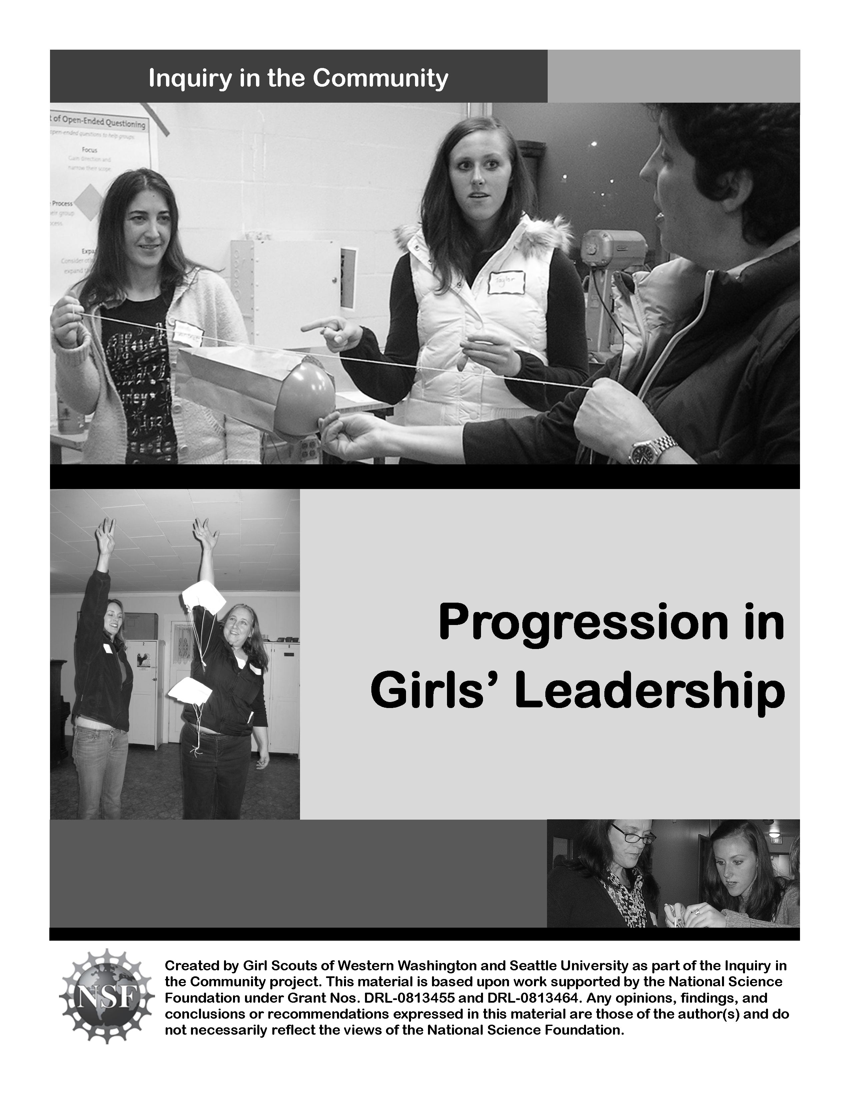

Girl Scout Leadership Experience

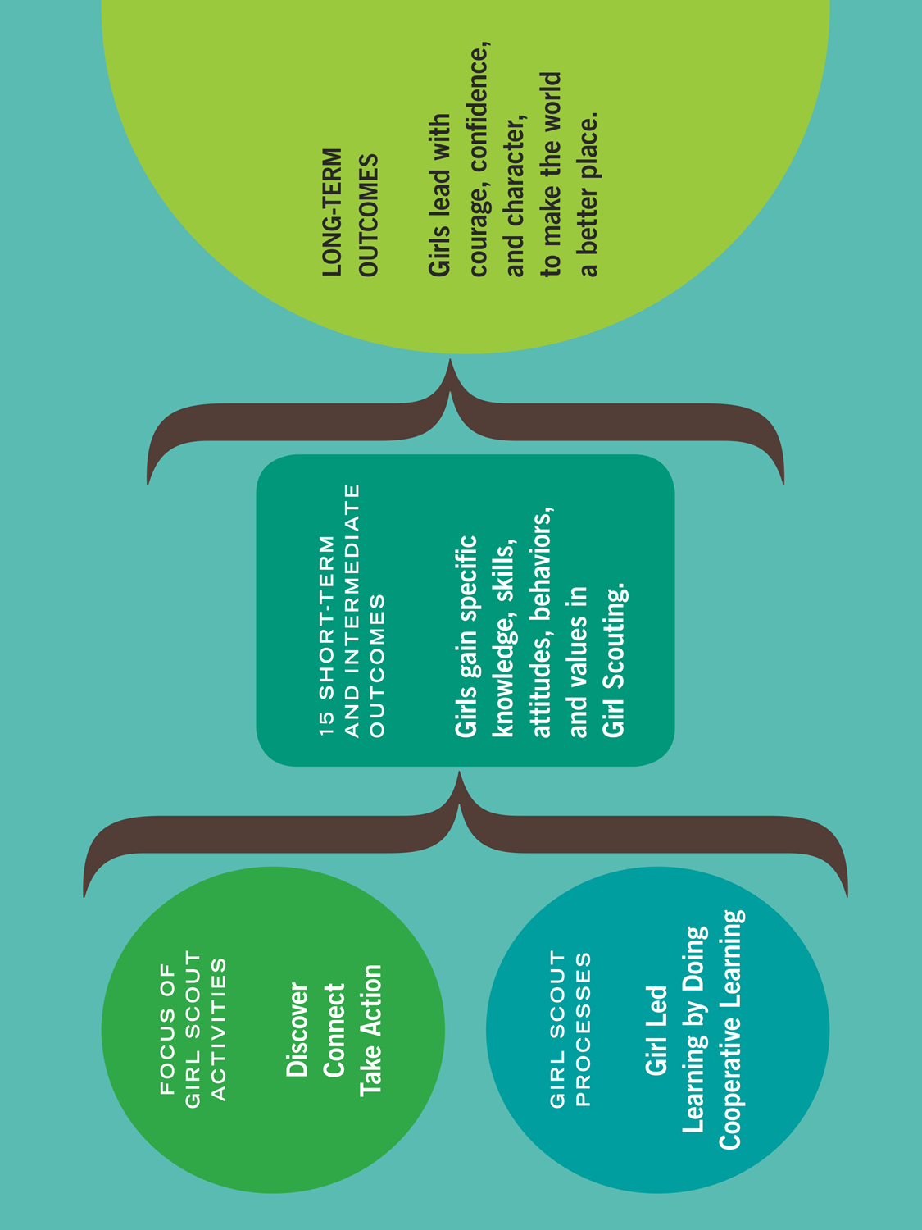

Girl Scout Leadership Experience: Processes in-Depth

The Girl Scout Processes
These processes are what make Girl Scout activities unique, fun, and different from school or other activities. The processes describe the “how” of how activities are planned and carried out.

Girl Led means that girls of every age take an active and grade-appropriate role in figuring out the what, where, when, why, and how of what they do. Adults coach and partner with girls to support them in making decisions; how “hands-on” adults are depends on the activity and girls’ experience level.

“Girl led” happens in three major ways. All three ways need to be present within a troop, camp, or event for girls to have a meaningful experience.
- Choice within an activity: girls make substantive decisions affecting how they do a particular activity. What ingredients do they use for cooking? How will they celebrate Juliette Low’s birthday? What animal shelter do they want to help with a take action project? How do they decide what kind of paper bag rocket to make?
- Choosing which activities to do: girls make choices about which activities they do in their troops, during an event, or during their time at camp. They choose the journey they do, adapt the journey activities to fit their interests, and select and plan their “side trips” (badges, field trips, petals, etc.).
- Learning to lead other girls: Older girls might learn to lead younger girls, or girls might learn to lead their peers. The girls doing the leading often need coaching to let the other girls make choices: both within an activity, and about which activities to do.

Learning by Doing is hands-on learning that engages girls in an ongoing cycle of action and reflection. When girls actively participate in meaningful activities and later reflect on them, they get a deeper understanding of concepts and mastery of skills.

Cooperative Learning is designed to promote sharing of knowledge, skills, and learning in an atmosphere of respect and cooperation. Girls work together on goals that can only be accomplished with the help of others, and share their insights, stories, and lessons learned with each other.

The Learning by Doing Process: Activity Cycle

Girl Scout activities go through cycles of action and reflection. When working with girls, it is helpful to think of an activity as having four different steps. By using these steps to frame our activities, we ensure that girls get chances to learn the basics about an activity or topic, have meaningful planning opportunities, have hands-on fun, and reflect on what they did.

Activity Cycle:

- Spark! Introduce an activity to spark interest and curiosity in a subject. This can happen two ways: adults can introduce a topic, or girls can suggest it. Often, the activity introduced is one from a journey or badge, which gives girls a basic understanding of a skill or concept. Girls might learn how to start seeds, make a craft, find out about the needs in their community, or cook a simple meal for camping.

- Plan After girls have some experience with the skill or activity, girls start thinking about how to make it their own. They decide what they want to do (What if I use different soil for my seeds? How can we help the food bank?) and plan how they want to do it.

- Do Girls get busy! They carry out their plan and see what happens.

- Reflect on what they did. They share what they did and learned with others: maybe other girls/adults in the group, their families, or the community. Reflections take many forms, from individual journaling to group slide shows and year-end parties.

The “do” and “reflect” steps often bring up new ideas, and the steps start all over again!

Exploring Leadership Progression: Characteristics

Characteristics of Each Station
A | B | C

Who controlled the…?
For each station, select who controlled each step of the activity: adult, girls, or both?

Station | A | B | C

Introduce

Plan – what to do

Plan – how to do it

Do
Issues and solutions

Reflection

Leadership Progression: Comparing Approaches

What did the adult do at each station?
A | B | C

When might you use each approach?
A | B | C

Progression in Action

Examples of different levels of girl and adult control

 | Mostly Adult Controlled |  |  |  | Mostly Girl Controlled
Introduce  “Who chooses what the initial activity is?” | Adults choose the initial activity. | Adults choose an activity based on girls’ interests. | Adults give girls options; girls choose an activity from those options. | Girls and adults generate ideas; girls choose which activity to pursue. | Girls generate ideas based on their interests; girls choose the activity.
Plan, part 1  “Who generates ideas and chooses what girls will do with this activity?” | Adults generate and choose the idea. | Adults make a list of ideas; girls pick which one(s) | Girls brainstorm ideas. Adults eliminate any unworkable ideas; girls choose from this list. | Girls brainstorm ideas. Adults guide girls in evaluating ideas to see if they’re “do-able.” Girls choose. | Girls brainstorm questions, evaluate them for “do-ability” and choose. Adults support as needed.
Plan, part 2  “Who plans the activity?” | Adults make the plan (what, when, where, etc.) | Adults do most of the planning. Adults give girls choices from certain options. | Adults provide framework for planning: how to vote, what decisions need to be made, delegation. Girls make a plan using this framework. | Adults give girls options for how to plan: different ways to vote, delegate, etc. Girls choose from these options, then plan. | Girls decide how they want to plan (delegation, decision making methods, etc.). Adults help girls identify decisions to make, and girls make them.
Do  “When girls are carrying out the activity, who identifies issues and creates solutions?” | Adults identify issues as they arise, and tell girls how to solve them. | Adults identify issues as they arise, and give girls options for how to solve them. Girls choose from these options. | Adults identify issues as they arise, and ask girls open-ended questions to help them find solutions. | Adults ask open-ended questions to help girls identify issues and find solutions. | Girls identify issues as they arise, problem-solve, and carry out solutions. Both girls and adults use open-ended questions to work through issues.
Reflect  “Who identifies what girls did and learned?” | Adults tell girls what they did and learned. | Adults tell girls what they did and learned; girls add additional thoughts. | Adults plan and lead a reflection; girls share what they did and learned. (Adults share their thoughts in the reflection as well.) | Adults identify ways to reflect (drawings, verbal, ceremonies); girls choose. Adults help girls reflect and are also included in the reflection. | Adults ask girls how they want to reflect. Girls identify ways to reflect, choose one, and carry it out. (Adults are included in the reflection as well.)

Age/experience level of the girls + complexity of the activity = the level of girl control

