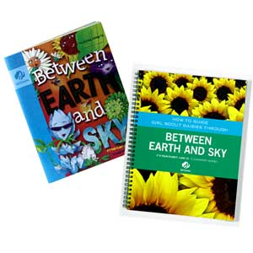
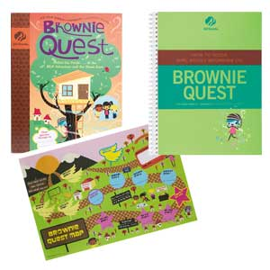



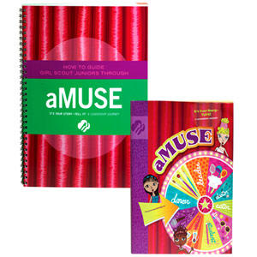
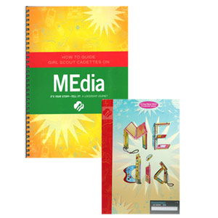

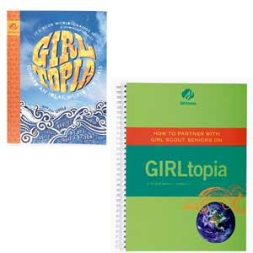
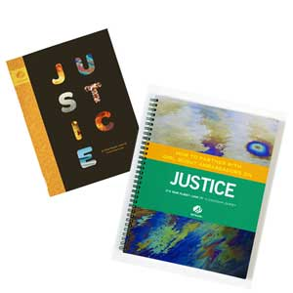

Working with Journeys

Participant Guide


Created by Girl Scouts of Western Washington and Seattle University as part of the Inquiry in the Community project. This material is based upon work supported by the National Science Foundation under Grant Nos. DRL-0813455 and DRL-0813464. Any opinions, findings, and conclusions or recommendations expressed in this material are those of the author(s) and do not necessarily reflect the views of the National Science Foundation.

Opening: Check-In

Simple objects or pictures can become powerful reflection tools. In this course, we used body parts as the basis for our opening check-in and closing reflection. The parts, and the questions we associated with them, are:

Head: What am I thinking? (Check-in) / What did I learn? (Closing)
Hand: What have I been doing? (Check-in) / What do I want to try? (Closing)
Heart: How do I feel? (Check-in) / What am I excited about? (Closing)

Objects and pictures can be used as a check-in and reflection tool for any group. Below are some ideas to get you started; look around your house or in the toy aisle and let your imagination run wild!

Daisies – Face Cards
Get three pieces of paper/cardstock. On one piece of paper, draw a smiley face; on another piece of paper, draw a face with a frown; and on the third, draw a face with a straight line for the mouth. When doing a check-in or reflection, girls pick the face that best represents how they’re feeling and explain why. This is good for Daisies because the cards clearly represent different emotions, and don’t require reading.

Brownies and Juniors – Questions with Objects
Brownies benefit from reflections like the “body part” activity described above. The objects can spark girls’ imaginations, and the accompanying questions provide clear direction for the kind of response you want (thoughts, feelings, what they’ve learned, or new ideas sparked by the activity.)

Juniors and Older – Objects as Metaphors
This check-in and reflection technique has unlimited possibilities. Select a few objects you have laying around the house; it helps if they are all the same type of object. Juniors relate well to stuffed/plastic animals, pictures of expressive faces, and familiar characters from books and movies. Try more abstract objects for older girls: simple toys, kitchen utensils, school supplies, pictures of landscapes, etc.

For a check-in, have girls explain “I’m feeling like __(the object)___ because ______.” For example: “I’m feeling like a horse right now because I want to run around!” To reflect at the end of an activity or meeting, have them relate the object to what they learned, how they are feeling now, or their favorite part of the activity. For example: “I’m picking the pencil because I really liked when we drew pictures of our rockets.”

Opening: Agenda and Creating Safe Spaces

Agenda
This workshop will explore ways to make journeys (and any activity!) fun and exciting for girls. Today we will:
- Start with a hands-on tour of the adult journey guides
- Explore how to make journeys amazing through a hands-on experience with the Girl Scout Processes
- Work together to find answers to the following questions:
  - What are journeys?
  - What are the processes?
  - How do we implement the processes with any activity?
  - How do we implement the processes with journeys and “side trips?”
- Reflect on what we’ve learned and how we plan to use it with girls

Group Agreement
Group agreements are powerful tools. When you or your girls work together to define expected behaviors (like listening, sharing, or including all girls in activities), everyone benefits. Girls make key choices about their group “rules” and how their group will run, and understand how they need to behave in Girl Scouts; adults get much-needed help in reinforcing desired behaviors. Try these tips for getting the most out of your group agreement:
- Phrase expectations in positive language, rather than negative. “Walk” works much better than “don’t run.” Girls are experts at finding exceptions to negative statements (“I wasn’t running, I was skipping!”).
- Use it early and often. Have girls write the “rules” on a big piece of paper, and have everyone (girls and adults) sign it. Bring it to each meeting.
- Have girls revisit it every few meetings: are there behaviors the girls (or adults) need to work on? Do you need to add or delete anything?
- If you are going on a trip, outing, or special activity, you might add to your group agreement (such as “always stay with your buddy”).
- Include expectations for adults, too. Girls will feel more comfortable when they know what they can expect from your adult team.

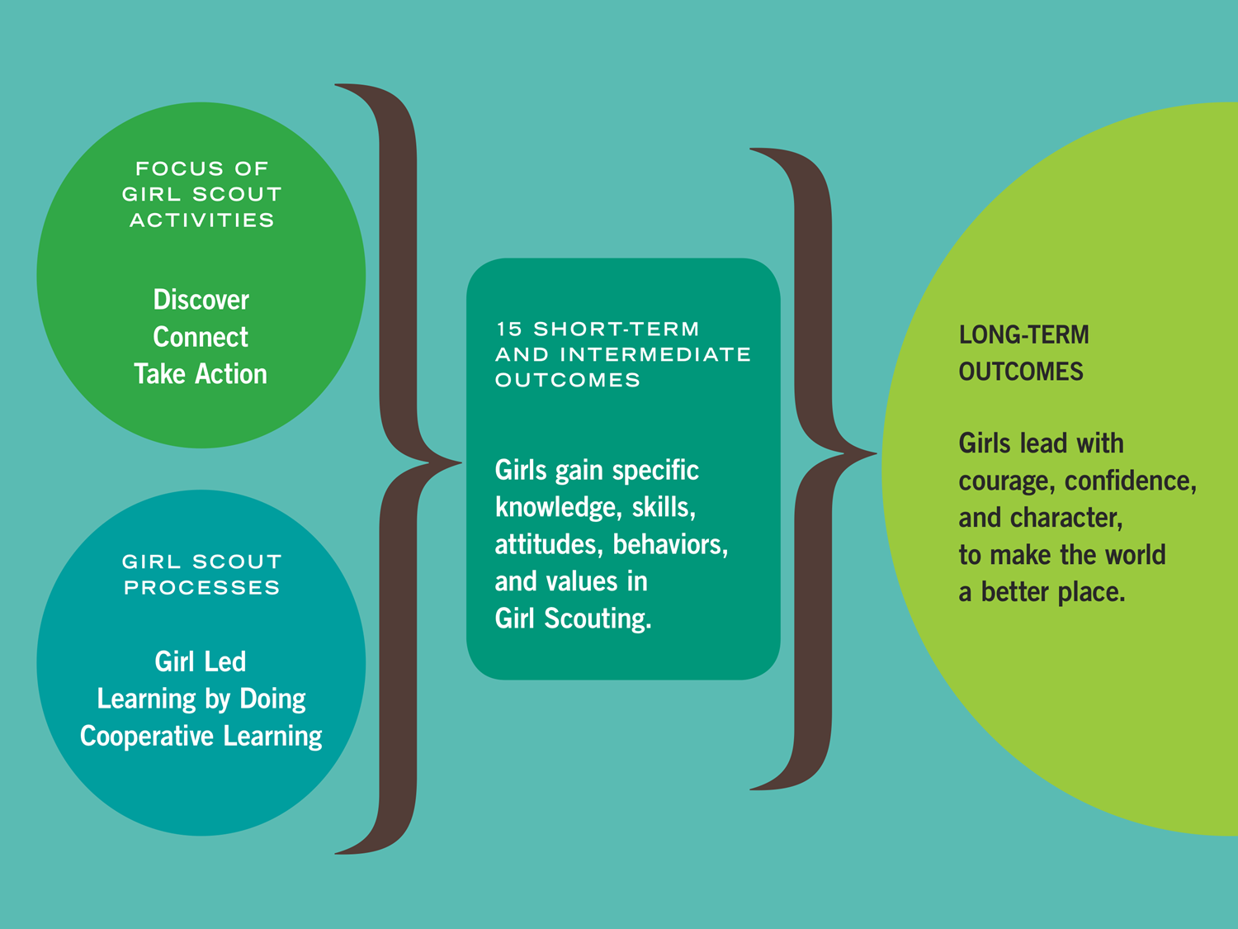
Girl Scout Leadership Experience

Words and phrases that jump out about the processes:

Girl Scout Leadership Experience: The Processes

The Girl Scout Processes
These processes are what make Girl Scout activities unique, fun, and different from school or other activities. The processes describe the “how” of how activities are planned and carried out.

Girl Led means that girls of every age take an active and grade-appropriate role in figuring out the what, where, when, why, and how of what they do. Adults coach and partner with girls to support them in making decisions; how “hands-on” adults are depends on the activity and girls’ experience level.

“Girl led” happens in three major ways. All three ways need to be present within a troop, camp, or event for girls to have a meaningful experience.
- Choice within an activity: girls make substantive decisions affecting how they do a particular activity. What ingredients do they use for cooking? How will they celebrate Juliette Low’s birthday? What animal shelter do they want to help with a take action project? How do they decide what kind of paper bag rocket to make?
- Choosing which activities to do: girls make choices about which activities they do in their troops, during an event, or during their time at camp. They choose the journey they do, adapt the journey activities to fit their interests, and select and plan their “side trips” (badges, field trips, petals, etc.).
- Learning to lead other girls: Older girls might learn to lead younger girls, or girls might learn to lead their peers. The girls doing the leading often need coaching to let the other girls make choices: both within an activity, and about which activities to do.

Learning by Doing is hands-on learning that engages girls in an ongoing cycle of action and reflection. When girls actively participate in meaningful activities and later reflect on them, they get a deeper understanding of concepts and mastery of skills.

Cooperative Learning is designed to promote sharing of knowledge, skills, and learning in an atmosphere of respect and cooperation. Girls work together on goals that can only be accomplished with the help of others, and share their insights, stories, and lessons learned with each other.

Experiencing the Processes: Activity Cycle

This activity goes through four different steps. By using these steps to frame our activities, we ensure that girls get chances to learn the basics about an activity or topic, have meaningful planning opportunities, have hands-on fun, and reflect on what they did.

Activity Cycle:

- Spark! Introduce an activity to spark interest and curiosity in a subject. This can happen two ways: adults can introduce a topic, or girls can suggest it. Often, the activity introduced is one from a journey or badge, which gives girls a basic understanding of a skill or concept. Girls might learn how to start seeds, make a craft, find out about the needs in their community, or cook a simple meal for camping.

- Question & Plan After girls have some experience with the skill or activity, girls start thinking about how to make it their own. They decide what they want to do (What if I use different soil for my seeds? How can we help the food bank?) and plan how they want to do it.

- Do Girls get busy! They carry out their plan and see what happens.

- Reflect on what they did. They share what they did and learned with others: maybe other girls/adults in the group, their families, or the community. Reflections take many forms, from individual journaling to group slide shows and year-end parties.

The “do” and “reflect” steps often bring up new ideas, and the steps start all over again!

Making the Processes Happen

When the processes happened…
Cooperative Learning

Learning by Doing

Girl Led

How we helped them happen…
Look at how the facilitator gave instructions and interacted, the activity steps, available supplies, and the environment (room set-up, etc.).
Cooperative Learning

Learning by Doing

Girl Led

Making the Processes Happen: More Ideas

Ideas for Planning and Decision-Making
- Sort Ideas: When faced with a large number of ideas (say, more than 5-10), see if you can group them into like categories before making a decision. You – and the girls – will have less to choose from, and then you can do another vote for the ideas within the category.
- Resource Check: You or the girls can do the resource check. For each idea, establish if you have the time and resources (people, materials, money) needed to do the idea. This process might be very quick (such as for the parachute activity) or in-depth (such as girls planning a trip.)
- Dream Box: If the idea isn’t feasible for now, write it down and place it in your group’s “dream box.” This might be a notebook or a physical box of ideas to pursue later.
- Object Voting (dot voting): There are many variations to fit a groups’ needs. Each person gets a number of votes (typically 3-5) and can use them how they want. They might put all their votes on one idea they really like or spread them out. You can use many objects as votes: stickers on a sheet of paper, slips of paper or other objects placed in little boxes or cups; or pen marks. If you want to ensure anonymity in voting, invite girls to come into the room one by one to cast their votes.
- Individual Choice: Some projects lend themselves to having girls pick the option they each prefer to work on. This is good for delegating parts of a bigger project, or for encouraging individual creativity.

Ideas for Reflecting
- Journaling: Girls can draw pictures or write in notebooks, in their journey books, or in a Girl Scout diary.
- Pair and Share: Pair girls with each other, and have them tell each other about their experience.
- Drawing: Girls love to draw, and drawing pictures is a great way to remember what you did. This is also good for younger girls who have more challenges with writing.
- Move to Your Choice: This can be used for reflection or decision-making. Designate a spot in the room for each statement/choice (e.g. “My favorite part of the trip was when we rode horses.”) Have girls stand next to the statement/choice they most agree with. For reflection, you can do this multiple times with different statements.

Customizing your Journey

Finding the Processes
First, find where the three processes are present in your journey activity:
Cooperative Learning

Learning by Doing

Girl Led

Customizing your Journey Activity
Now, get creative! How could you add more of each process to meet the needs of your girls?

Cooperative Learning

Learning by Doing

Girl Led

Adding Awesome Side Trips

Side Trips with Common Girl Scout Activities
Time to get creative! Think about the theme of the journey you’re using. How might you relate these three common activities to the theme of your journey?
Cookie Program

Outdoor Adventures

Thinking day

Even More Side Trips
Put your “girl hat” on – what would your inner girl suggest for other side trips related to the theme? What could you do, where could you go, what could you make, who could you meet?

