**Rain Gardens of SU: Flag Pole Lawn Rain Garden**

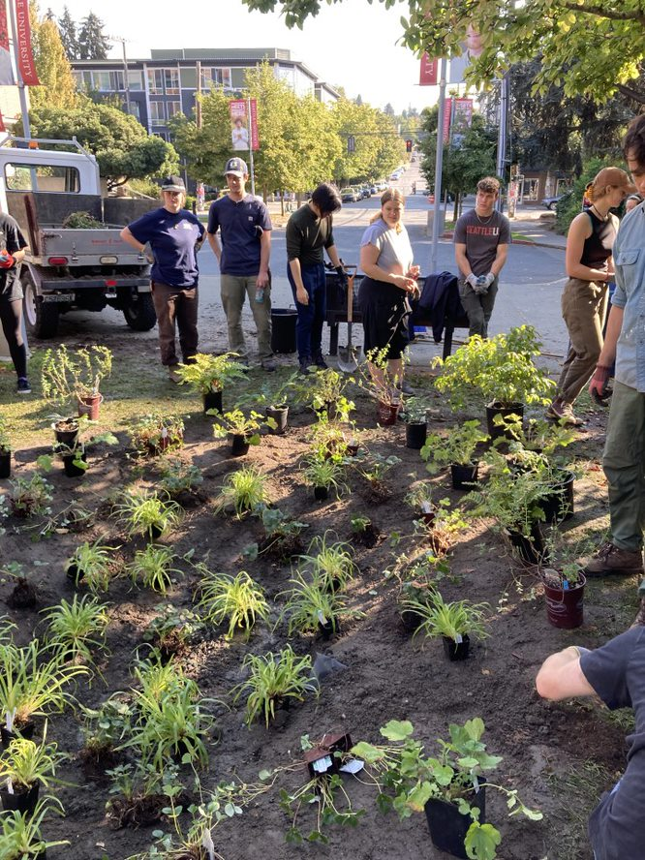

The students of Seattle University’s chapter of Engineer’s for a Sustainable World constructed a small detention rain garden on SU’s campus with the help of SU Grounds. The project’s goal is to give students the opportunity to design, plan, and build a rain garden while addressing stormwater concerns in an urban area. The rain garden features native plantings chosen by students and approved of by SU Grounds. The project began with design sessions assisted by landscape architecture professionals from the Berger Partnership and Urban Rain Design.

The rain garden supports biodiversity, ecosystems, plants with staggered blooming schedules to increase habitat for pollinators throughout the year.

Washington Native Plant Society awarded educational grant funding for the purchase of plants and drainage materials.