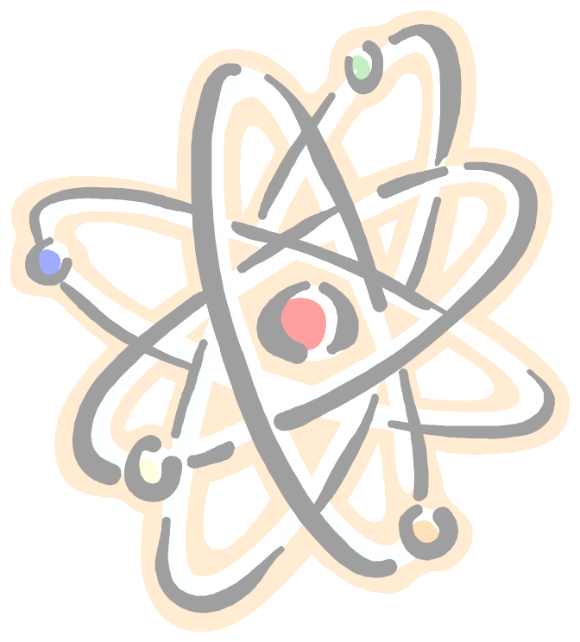
How to Study Physics

Remember: Physics is a problem-solving discipline; all of the concepts and theories that you will learn will be applied towards solving problems.

1. Overview
- Look at syllabus to see what chapters are assigned and what concepts will be covered in class.

2. Lecture
- Read the assigned sections to be discussed before the lecture, with an emphasis on chapter headings, subtitles, new formulas, diagrams, and captions. You will be more prepared to understand the lecture.
- Before class, glance over your notes from the last lecture so you will be able to integrate the current lecture topic with past topics.
- If you are prepared, you'll be able to ask relevant questions during the lecture.
- After the lecture, review and edit your notes. Leave space in your notes during. the lecture to do this (no need to rewrite). Try to link lecture notes with overall relationships to major topics in physics.

3. Reading the Text
- Skim over homework to see what principles are pertinent.
- Read actively with questions in mind (use Post-it notes to write your questions on and stick the notes onto the section in the book; then show your professor the section where you have questions).
- Stop periodically and recall material.
- After reading a section, note how it applies directly to homework.
- Understand how the given equations relate to basic laws of physics.
- When a specific problem is analyzed in detail, look over the problem and try to understand how the general concepts apply to the specific problem.

4. Problem Solving
- Steps in solving physics problems:
  - Read the problem--make sure you understand what is being asked.
  - Make a drawing of the problem:
    - Identify known quantities
    - Identify unknown quantities that you are seeking and quantities that you can calculate to solve for the unknown
Over →
    - Make sure all quantities are written in consistent units (usually SI units)
  - Establish what principles relate to the given problem. This is especially important when the solution must be calculated indirectly from given information.
  - Calculate the solution. In multiple part problems, be able to separate what information will be relevant to solve for a particular part of the problem.
    - Calculate values of parameters obtained from given info
    - Plug values of parameters into applicable formulas
  - Criticize your solution to see if it makes sense--this will develop your intuition.
  - After completing problems, check over solutions. Make note of methods, missed steps.

5. Test Preparation Steps
- Start reviewing at least a week before the test.
- Quickly review notes and syllabus to see what has been emphasized.
- Quickly review solutions to homework problems and assigned chapters
- Generate a list of themes, principles, types of problems covered.
- Review actively. Try to look at all possible ways that a principle can be applied.
- Practice lots of different problems!
- Work with your study group to discuss principles and types of problems that will be covered on the test.
- Ask your professor for clarification of confusing topics.

Adapted from material by David R. Hubin and Charles Riddell, "How to Study Physics"
(Irvine: Learning Skills Center, University of California)

