STRENGTHEN YOUR READING SKILLS

Reading college texts with understanding requires an approach based on basic principles of learning and remembering. Experts describe this approach in various ways - a summary follows:


SQ3R: an easy-to-follow systematic approach to textbook reading. The steps are:
Survey, Question, Read (to find answers), Recite, Review.

Muscle Reading: an approach which can be modified to fit your purpose and your style. It includes a choice between taking separate text notes and marking the text by highlighting and making margin notes. The steps are:
- Preview
- Outline (if you're taking separate notes, use headings to make an outline)
- Question (you could write down questions)
- Read
- Underline (mark the text)
- Answer (if you wrote down questions, write the answers; if you made an outline, fill in details
under the headings)
- Recite (check understanding orally or in writing)
- Review (before closing the book)
- Review Again (make review a regular part of your study)
from Becoming a Master Student by David Ellis

Reading Difficult Books: an approach similar to SQ3R:
Read through superficially and quickly first (use preface, contents, headings to understand the organization). Sample first, eat heartily later!
- Check the meaning of key words
- Reread more slowly and carefully. Look for the thesis or main point.
- Highlight the thesis.
- Reread for structure, looking for how the author put the ideas together.
- Test yourself continually
- Think with the author.
- Interact with the material.
from Efficient Reading Strategies by GeorgeUsova

ADULT Method: an approach to texts
Ask questions before you read
Determine and Document where the questions are answered
Understand what the answers are by reading the material
Learn the answers by reciting or writing
Test yourself (in a study group or by yourself)
from The Mountain is High: Success Strategies for Adult Learners by Smith and Walter
Over →

Reading and Study: A Simplified System
Survey to get an overview and raise questions as you do
Read to understand and select what needs to be remembered
Restate and organize, then study to retain the material
(ways to organize information include labeling in the margin,
outlining, making flashcards, writing key words or questions
in the margin of your text notes, and mapping)
Summarize what you've read
from Effective Reading in a Changing World by Wassman and Rinsky

Ten Ways to Improve Reading Comprehension:
1. Read with expression
2. Build a strong, precise vocabulary
3. Increase your background by reading the "great books"
4. Before reading, recall what you already know about the subject
5. Recognize the function of topic sentences
6. Know the six types of paragraphs: introduction, definition, transition, information,
illustration, conclusion
7. Know the basic organizational patterns: time order, process, spatial relationship, increasing and decreasing importance, cause/effect, and comparison/contrast
8. Summarize at the end of each page
9. Survey and list questions before reading
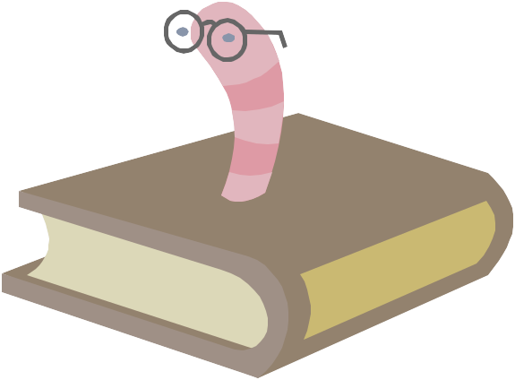
10. Know pivotal words (also, moreover, similarly, to illustrate, etc.) from How to Study in College by Walter Pauk

Reading Faster with Comprehension
Preview the material
Anticipate what will come next
Know what you want to get from the material
Look for main ideas
Recognize signal words (however, if/then, next, etc.)
Intend to remember. Summarize main points regularly
Set goals for improving rate and comprehension
from A Guidebook for Teaching Study Skills and Motivation by Bragstad and Stumpf

